

**Dharmsinh Desai University**

**MCA SEM-II**

**DATA STRUCTURE USING C**

**ASSIGNMENT-2**

|  |  |  |
| --- | --- | --- |
| **ROLL NO** | **:** | **MA006** |
| **NAME** | **:** | **SHIVANI KACHHIYA** |
| **ID** | **:** | **18MAPOG001** |

**SUBMITTED TO**

**Prof. Himanshu Purohit**

1. Create function called swap ( ), which swaps the number values. Create a function pointer which points to a swap ( ) function and call function using pointer. Write a program which also checks whether the two number entered by user is palindrome or not after swaping.

* **Source code**

#include<stdio.h>

#include<string.h>

void swap(int *x1,int *x2)

{

int temp;

temp=*x1;

*x1=*x2;

*x2=temp;

}

void palindrom(int x1)

{

int n1=x1;

int d=0;

printf("value of N1 : %d\n",x1);

while(x1 != 0)

{

d = d * 10;

d = d + x1%10;

x1= x1/10;

}

if(n1 == d)

{

printf(" %d is Palindrom \n",n1);

}

else

{

printf(" %d is not palindrom \n",n1);

}

}

void read_from_file()

{

FILE *in_file;

int n,no[2];

in_file = fopen("swap.txt","r");

if(in_file == NULL)

{

printf("error\n");

}

int i=0;

while(fscanf(in_file,"%d",&n) != EOF)

{

no[i]=n;

i++;

}

fclose(in_file);

}

int main()

{

int n1,n2,no[2];

read_from_file();

n1=no[0];

n2=no[1];

void (*p)(int,int)=&swap;

(*p)(&n1,&n2);

printf("\n");

printf("Check Two numbers are palindrom or not :\n");

printf("Number 1 : \n");

palindrom(n1);

printf("\n");

printf("Number 2 : \n");

palindrom(n2);

}

* **Output :**

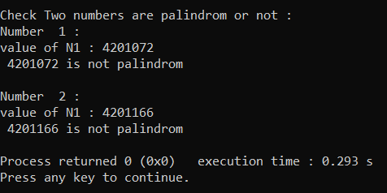

1. Implement linked list to create and manage a set of elements. Set of elements contains integer values i.e. S = {4,5,6}. Also implement a method which shows all possible subsets of the created set by user i.e. {{4}, {5}, {6}, {4,5}, {4,6}, {5,6}, {4,5,6}, {Ø}}.

* **Source code:**

#include<stdio.h>

#include<stdlib.h>

struct node{

int data;

struct node *next;

}*head=NULL;

int c=0;

void insert(int data)

{

struct node *temp,*newnode;

newnode=(struct node*)malloc(sizeof(struct node));

newnode->data=data;

if(head == NULL)

{

head=newnode;

newnode->next=NULL;

}

else

{

temp=head;

while(temp->next != NULL)

{

temp=temp->next;

}

temp->next=newnode;

newnode->next=NULL;

}

}

void display()

{

struct node *temp;

if(head == NULL)

{

printf("LINK LIST IS EMPTY\n");

}

temp=head;

while(temp != NULL)

{

printf("%d ->",temp->data);

temp=temp->next;

}

}

int length()

{

struct node *temp;

temp=head;

while(temp != NULL)

{

c++;

temp=temp->next;

}

return c;

}

void powerset(struct node *v, struct node *up)

{

if(v != NULL)

{

printf("%d",head->data);

head=head->next;

}

else

{

struct node *t,*q;

t=v->next;

q=up->next;

powerset(t,q);

powerset(t,q);

}

}

void main()

{

insert(50);

insert(60);

printf("\n\n");

struct node *list;

list=head;

int n;

n=length();

powerset(list,head);

}

* **Output :**

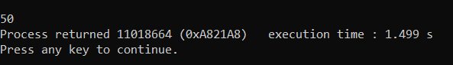

1. Write a program to check the balance of parenthesis if an expression. Implement required data structure for the same.

* **Source code :**

#include <stdio.h>

#include <string.h>

#define MAX_SIZE 100

int top=-1;

char arr[MAX_SIZE];

int isEmpty(){

if(top == -1){

return 1;

}else{

return 0;

}

}

int isFull(){

if(top == MAX_SIZE-1){

return 1;

}else{

return 0;

}

}

void push(char item){

if(isFull())

{

printf("Stack is full");

}

else

{

top++;

arr[top] = item;

}

}

void pop(){

if(isEmpty()){

printf("Stack is empty");

}else{

top--;

}

}

char gettop()

{

return arr[top];

}

int ArePair(char opening,char closing)

{

if(opening == '(' && closing == ')') return 1;

else if(opening == '{' && closing == '}') return 1;

else if(opening == '[' && closing == ']') return 1;

return 0;

}

void read_from_file()

{

FILE *in_file;

char in_expr;

in_file = fopen("parenthesis.txt","r");

if(in_file == NULL)

{

printf("error\n");

}

printf("\nGiven Code Below to find Any mis Paranthesis \n\n");

while(fscanf(in_file,"%c",&in_expr) != EOF)

{

printf("%c",in_expr);

if(in_expr == '(' || in_expr == '{' || in_expr == '[')

{

push(in_expr);

}

else if(in_expr == ')' || in_expr == '}' || in_expr == ']')

{

char a = gettop();

if(isEmpty() || !ArePair(gettop(),in_expr))

{

printf("\nResult - Invalid expression - Not a Balanced one !");

return 0;

}

else

{

pop();

}

}

}

fclose(in_file);

}

void main()

{

read_from_file();

if(isEmpty()){

printf("\n\nResult - Valid expression - Perfectly Balanced !");

}else{

printf("\n\nResult - Invalid expression - Not a Balanced one !");

}

printf("\n");

}

* **Output :**

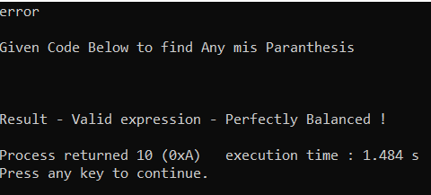

1. Implement a program to generate a linked list. For any unsorted linked list, write a method that will delete any duplicates from the linked list without using a temporary buffer.

* **Source code :**

#include<stdio.h>

#include<stdlib.h>

struct node{

int data;

struct node*next;

}*head=NULL;

void insert(int n)

{

struct node *temp,*newnode;

newnode=(struct node*)malloc(sizeof(struct node));

newnode->data=n;

if(head == NULL)

{

head=newnode;

newnode->next=NULL;

}

else

{

temp=head;

while(temp->next != NULL)

temp=temp->next;

temp->next=newnode;

newnode->next=NULL;

}

}

void read_from_file()

{

FILE *in_file;

int n;

in_file = fopen("Link_list.txt","r");

if(in_file == NULL)

{

printf("error\n");

}

while(fscanf(in_file,"%d",&n) != EOF)

{

insert(n);

}

fclose(in_file);

}

void write_into_file()

{

FILE *out_file;

out_file = fopen("Link_list.txt","w");

if(out_file == NULL)

{

printf("error\n");

}

struct node * temp;

temp=head;

while(temp != NULL)

{

fprintf(out_file,"%d\n",temp->data);

temp=temp->next;

}

fclose(out_file);

}

void find_duplicate()

{

struct node *temp ,*temp1 ,*dup;

temp=head;

while(temp != NULL)

{

temp1=temp;

while(temp1->next != NULL)

{

if(temp->data == temp1->next->data)

{

dup=temp1->next;

temp1->next=temp1->next->next;

free(dup);

}

else

{

temp1=temp1->next;

}

}

temp=temp->next;

}

}

void display()

{

struct node *temp;

if(head == NULL)

{

printf("List is Empty \n");

return;

}

temp=head;

while(temp != NULL)

{

printf("| %d | -> ",temp->data);

temp=temp->next;

}

}

void main()

{

read_from_file();

printf("Link List : \n");

display();

find_duplicate();

write_into_file();

printf("\nAfter Removing The Duplicate Entry :\n");

display();

}

* Output :

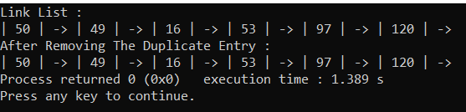

1. Write a program to create a binary tree. Implement required method to generate a binary tree from user inputs and to display binary tree using level order and pre order traversals.

* **Source code :**

#include<stdio.h>

#include<stdlib.h>

struct node

{

int data;

struct node *left;

struct node *right;

};

struct node* root;

struct node* insert(struct node* r, int data)

{

if(r==NULL)

{

r = (struct node*) malloc(sizeof(struct node));

r->data = data;

r->left = NULL;

r->right = NULL;

return r;

}

else if(data < r->data){

r->left = insert(r->left, data);

}

else {

r->right = insert(r->right, data);

}

return r;

}

void Preorder(struct node *root)

{

if(root != NULL)

{

printf("[ %d ] -> ",root->data);

Preorder(root->left);

Preorder(root->right);

}

}

//read data from file

void read_from_file()

{

FILE *in_file;

int n;

in_file = fopen("BSTtree.txt","r");

if(in_file == NULL)

{

printf("error101\n");

}

while(fscanf(in_file,"%d",&n) != EOF)

{

root=insert(root,n);

}

fclose(in_file);

}

int queue[100];

int front=0;

int rear=-1;

void enQueue(struct node *new_node)

{

queue[rear++] = new_node;

}

struct node *deQueue()

{

if(front == rear)

{

return NULL;

}

else

{

return queue[front++];

}

}

void printLevelOrder(struct node* root)

{

struct node *temp_node = root;

enQueue(root);

while (temp_node != NULL)

{

printf("[ %d ] - > ", temp_node->data);

if (temp_node->left != NULL)

{

enQueue(temp_node->left);

}

if (temp_node->right != NULL)

{

enQueue(temp_node->right);

}

temp_node = deQueue();

}

}

int main()

{

read_from_file();

printf("\n PreOrder Binary Tree : \n");

Preorder(root);

printf("\n\n");

printf("\n Level Binary Tree : \n");

printLevelOrder(root);

printf("\n\n");

}

* **Output :**

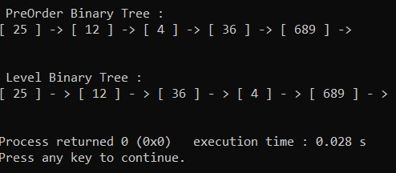

1. Given two values v1 and v2 (where v1 < v2) within a Binary Search Tree. Print all the keys of tree in range v1 to v2. i.e. print all x such that v1<=x<=v2 and x is a element of given BST. (Create a Binary Search Tree by any method).

* **Source code :**

#include<stdio.h>

#include<stdlib.h>

struct node

{

int data;

struct node *left;

struct node *right;

};

struct node* root;

struct node* insert(struct node* r, int data)

{

if(r==NULL)

{

r = (struct node*) malloc(sizeof(struct node));

r->data = data;

r->left = NULL;

r->right = NULL;

return r;

}

else if(data < r->data){

r->left = insert(r->left, data);

}

else {

r->right = insert(r->right, data);

}

return r;

}

void Print(struct node *root, int k1, int k2)

{

if ( NULL == root )

return;

if ( k1 < root->data )

Print(root->left, k1, k2);

if ( k1 <= root->data && k2 >= root->data )

printf("%d ", root->data );

if ( k2 > root->data )

Print(root->right, k1, k2);

}

//read data from file

void read_from_file()

{

FILE *in_file;

int n;

in_file = fopen("BSTtree.txt","r");

if(in_file == NULL)

{

printf("error101\n");

}

while(fscanf(in_file,"%d",&n) != EOF)

{

root=insert(root,n);

}

fclose(in_file);

}

void Display(struct node* root)

{

if(root != NULL)

{

printf("%d \t",root->data);

Display(root->left);

Display(root->right);

}

}

int main()

{

int k1,k2;

read_from_file();

printf("\nBinary Tree : \n");

Display(root);

printf("\n\nEnter First Number : ");

scanf("%d",&k1);

printf("\nEnter First Number : ");

scanf("%d",&k2);

printf("\n");

printf("Possible Keys Range Between %d and %d \n",k1,k2);

printf("\n");

Print(root,k1,k2);

printf("\n\n");

}

* **Output:**

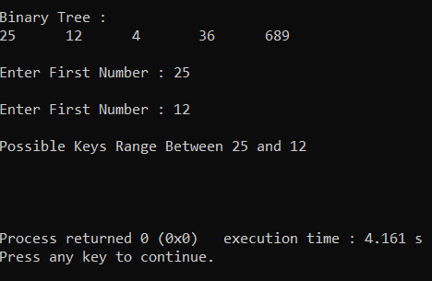

1. Write a program to create a binary tree. Implement required method to generate a binary tree from user inputs and check whether the Binary Tree is a perfect binary tree.

#include<stdio.h>

#include<stdlib.h>

struct tnode{

int data;

struct tnode *lchiled;

struct tnode *rchiled;

};

//insert new node

struct tnode *Create(struct tnode *p,int value)

{

struct tnode *temp,*temp1;

//For create Root node

if(p == NULL)

{

p=(struct tnode*)malloc(sizeof(struct tnode));

if(p == NULL)

{

printf("Error : Allocating Memory \n");

exit(0);

}

else

{

p->data = value;

p->rchiled=NULL;

p->lchiled=NULL;

}

}

//if Root Node Exit

else

{

temp=p;

while(temp != NULL)

{

temp1=temp;

if(temp1->data > value)

{

temp=temp->lchiled;

}

else

{

temp=temp->rchiled;

}

}

if(temp1->data > value)

{

temp1->lchiled=(struct tnode*)malloc(sizeof(struct tnode));

temp1=temp1->lchiled;

if(temp1 == NULL)

{

printf("Error : Allocating Memory \n");

exit(0);

}

else

{

temp1->data=value;

temp1->rchiled=temp1->lchiled=NULL;

}

}

else

{

temp1->rchiled=(struct tnode*)malloc(sizeof(struct tnode));

temp1=temp1->rchiled;

if(temp1 == NULL)

{

printf("Error : Allocating Memory \n");

exit(0);

}

else

{

temp1->data=value;

temp1->rchiled=temp1->lchiled=NULL;

}

}

}

return(p);

}

int findADepth(struct tnode *node)

{

int d = 0;

while (node != NULL)

{

d++;

node = node->lchiled;

}

return d;

}

int isPerfectRec(struct tnode* root, int d, int level)

{

if (root == NULL)

return 1;

if (root->lchiled == NULL && root->rchiled == NULL)

return (d == level+1);

if (root->lchiled == NULL || root->rchiled == NULL)

return 0;

return isPerfectRec(root->lchiled, d, level+1) &&

isPerfectRec(root->rchiled, d, level+1);

}

int isPerfect(struct tnode *root)

{

int d = findADepth(root);

return isPerfectRec(root,d,0);

}

struct tnode *root;

//read data from file

void read_from_file()

{

FILE *in_file;

int n;

in_file = fopen("BSTtree.txt","r");

if(in_file == NULL)

{

printf("error101\n");

}

printf("Given Binary Tree : \n\n");

while(fscanf(in_file,"%d",&n) != EOF)

{

printf("%d\t",n);

root=Create(root,n);

}

fclose(in_file);

}

void main()

{

read_from_file();

printf("\n\n");

if (isPerfect(root))

printf("This Binary Tree is Perfect \n");

else

printf("This Binary Tree is Not Perfect \n");

printf("\n");

}

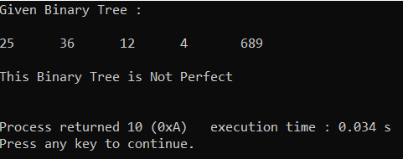

1. Write a program to implement stack with all basic operations using linked list.

#include<stdio.h>

#include<stdlib.h>

struct node{

int data;

struct node *next;

}*head=NULL;

void push(int item)

{

struct node *newnode;

newnode=(struct node*)malloc(sizeof(struct node));

newnode->data=item;

if(head == NULL)

{

head=newnode;

newnode->next=NULL;

}

else

{

newnode->next=head;

head=newnode;

}

}

void pop()

{

struct node *temp;

if(head==NULL)

{

printf("LIST IS EMPTY\n");

}

temp=head;

head=temp->next;

free(temp);

}

void Display()

{

struct node *temp;

temp=head;

if(head == NULL)

{

printf("LINK LIST IS EMPTY\n");

}

printf("\t");

while(temp != NULL)

{

printf("| %d | -> ",temp->data);

temp=temp->next;

}

printf("\n");

}

void write_into_file()

{

FILE *out_file;

out_file = fopen("number.txt","w");

struct node *temp;

temp=head;

if(head==NULL)

{

printf("\tQueue is Empty \n");

}

while(temp != NULL)

{

fprintf(out_file,"%d\n",temp->data);

temp=temp->next;

}

fclose(out_file);

}

void read_from_file()

{

FILE *in_file;

int n;

in_file = fopen("number.txt","r");

if(in_file == NULL)

{

printf("error\n");

}

while(fscanf(in_file,"%d",&n) != EOF)

{

// fscanf(in_file,"%d",&n1);

push(n);

}

fclose(in_file);

}

void main()

{

read_from_file();

int ch,item;

printf("\t1. PUSH\n");

printf("\t2. POP\n");

printf("\t3. DISPLAY\n");

printf("\t4. EXIT\n");

do{

printf("\tEnter Your Choice : ");

scanf("%d",&ch);

switch(ch)

{

case 1:

printf("\tEnter Data : ");

scanf("%d",&item);

push(item);

break;

case 2:

pop();

write_into_file();

break;

case 3:

Display();

break;

case 4:

break;

}

}while(ch!=4);

}

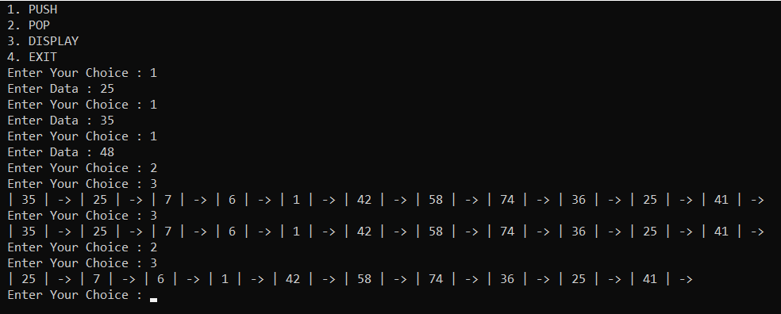

1. Write a program to implement Queue with all basic operations using linked list.

#include<stdio.h>

struct node{

int data;

struct node *next;

}*head=NULL;

void insert(int item)

{

struct node *newnode;

newnode=(struct node*)malloc(sizeof(struct node));

newnode->data=item;

if(head == NULL)

{

head=newnode;

newnode->next=NULL;

}

else

{

newnode->next=head;

head=newnode;

}

}

void Delete()

{

struct node *temp;

if(head == NULL)

{

printf("Queue is Empty \n");

}

temp=head;

while(temp->next->next != NULL)

{

temp=temp->next;

}

temp->next=NULL;

}

void display()

{

struct node *temp;

temp=head;

if(head==NULL)

{

printf("Queue is Empty \n");

}

printf("\t");

while(temp != NULL)

{

printf("| %d | -> ",temp->data);

temp=temp->next;

}

printf("\n");

}

void write_into_file()

{

//printf("write_into_file()\n");

FILE *out_file;

out_file = fopen("number.txt","w");

struct node *temp;

temp=head;

if(head==NULL)

{

printf("\tQueue is Empty \n");

}

while(temp != NULL)

{

fprintf(out_file,"%d\n",temp->data);

temp=temp->next;

}

fclose(out_file);

}

void read_from_file()

{

FILE *in_file;

int n;

in_file = fopen("number.txt","r");

if(in_file == NULL)

{

printf("error\n");

}

while(fscanf(in_file,"%d",&n) != EOF)

{

// fscanf(in_file,"%d",&n1);

insert(n);

}

fclose(in_file);

}

void main()

{

read_from_file();

int ch,item;

printf("1. INSERT\n");

printf("2. DELETE\n");

printf("3. DISPLAY\n");

printf("4. EXIT\n");

do{

printf("Enter Your Choice : ");

scanf("%d",&ch);

switch(ch)

{

case 1:

printf("\tEnter Data : ");

scanf("%d",&item);

insert(item);

break;

case 2:

Delete();

write_into_file();

break;

case 3:

display();

break;

case 4:

break;

}

}while(ch!=4);

}

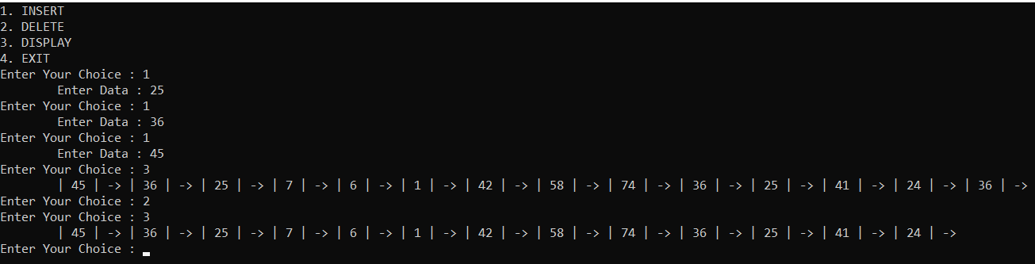

1. Write a program to implement stack with required operations using array.

#include<stdio.h>

#define SIZE 100

int stack[SIZE];

int top=-1;

void push(int item)

{

if(top >= SIZE-1)

{

printf("\nStack Overflow.");

}

else

{

top = top+1;

stack[top] = item;

write_into_file();

}

}

int pop()

{

int item;

if(top <0)

{

printf("stack under flow:");

}

else

{

item = stack[top];

printf("\t %d : DELETE\n",item);

top = top-1;

return(item);

}

}

void display()

{

if(top==-1)

{

printf("\tSTACK IS EMPTY\n");

}

int i;

for(i=top;i>=0;i--)

{

printf("\t| %d |\n",stack[i]);

}

}

void write_into_file()

{

FILE *out_file;

out_file = fopen("number.txt","w");

if(out_file == NULL)

{

printf("error\n");

}

int i=0;

for(i=top;i>=0;i--)

{

fprintf(out_file,"%d\n",stack[i]);

}

fclose(out_file);

}

void read_from_file()

{

FILE *in_file;

int n;

in_file = fopen("number.txt","r");

if(in_file == NULL)

{

printf("error\n");

}

while(fscanf(in_file,"%d",&n) != EOF)

{

push(n);

}

fclose(in_file);

}

void main()

{

read_from_file();

int ch,data;

printf("1. PUSH\n");

printf("2. POP\n");

printf("3. DISPLAY\n");

printf("4. EXIT\n");

do{

printf("Enter Your Choice : ");

scanf("%d",&ch);

switch(ch)

{

case 1:

printf("Enter Data : ");

scanf("%d",&data);

push(data);

break;

case 2:

pop();

write_into_file();

break;

case 3:

display();

break;

case 4:

break;

default :

printf("Enter Proper Choice \n");

break;

}

}while(ch!=4);

}

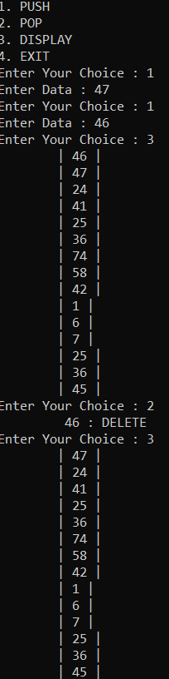

1. Write a program to implement Queue with required operations using array.

#include<stdio.h>

#define SIZE 100

int queue[SIZE];

int front=-1;

int rear=-1;

void insert(int item)

{

if(rear > SIZE)

printf("\tQueue is Overflow : \n");

else

{

if (front == - 1)

front = 0;

rear++;

queue[rear]=item;

write_into_file();

}

}

void Delete()

{

if(front > rear)

printf("\tQueue is Underflow : \n");

else

{

printf("\tDelete : %d\n",queue[front]);

front++;

}

}

void Display()

{

int i;

if(rear == -1 || front > rear)

printf("\tQueue is Empty \n");

printf("\t");

for(i=front;i<=rear;i++)

printf("| %d | ",queue[i]);

printf("\n\n");

}

void write_into_file()

{

FILE *out_file;

out_file = fopen("number.txt","w");

if(out_file == NULL)

{

printf("error\n");

}

int i=0;

for(i=front;i<=rear;i++)

{

fprintf(out_file,"%d\n",queue[i]);

}

fclose(out_file);

}

void read_from_file()

{

FILE *in_file;

int n;

in_file = fopen("number.txt","r");

if(in_file == NULL)

{

printf("error\n");

}

while(fscanf(in_file,"%d",&n) != EOF)

{

insert(n);

}

fclose(in_file);

}

void main()

{

read_from_file();

printf("QUEUE OPERATION USING FILE\n");

printf("1.INSERT\n");

printf("2.DISPLAY\n");

printf("3.DELETE\n");

printf("4.EXIT\n\n");

int ch;

do{

printf("Enter Your Choice : " );

scanf("%d",&ch);

switch(ch)

{

case 1:

{

int d;

printf("\tEnter Data : ");

scanf("%d",&d);

insert(d);

break;

}

case 2:

Display();

break;

case 3:

Delete();

write_into_file();

break;

case 4:

break;

default:

printf("\tEnter Proper Choice :\n");

break;

}

}while(ch != 4);

}

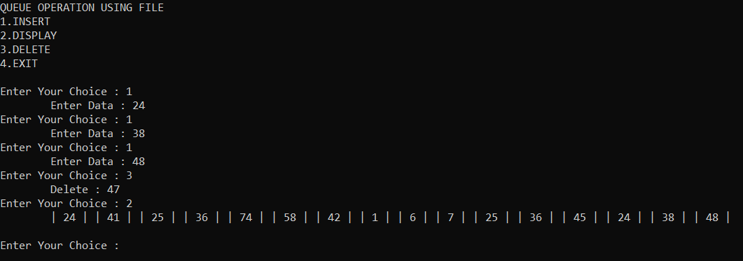

1. Write a program to check whether the string is palindrome or not. Use Stack Data Structure for the same.

#include<stdio.h>

#include<string.h>

#define SIZE 100

int stack[SIZE];

int top=-1;

char str[20];

void push(char c)

{

if(top > SIZE)

printf("Stack is OverFlow \n");

else

{

top++;

stack[top]=c;

}

}

char pop()

{

if(top == -1)

printf("Stack is Underflow \n");

else

{

char x=stack[top];

top--;

return x;

}

}

void read_from_file()

{

FILE *in_file;

int n;

in_file = fopen("string.txt","r");

if(in_file == NULL)

{

printf("error\n");

}

int i=0;

printf("Given String is :\n");

while(fscanf(in_file,"%c",&n) != EOF)

{

printf("%c",n);

str[i]=n;

push(n);

i++;

}

fclose(in_file);

}

int palindrom()

{

char pal[20];

int j=0;

while(top != -1)

{

pal[j]=pop();

j++;

}

if(strcmp(str,pal) == 0)

return 1;

else

return 0;

}

void main()

{

read_from_file();

printf("\n");

int res;

res = palindrom();

if(res == 1)

printf("String is Palindrom \n");

else

printf("String is Not Palindrom \n");

}

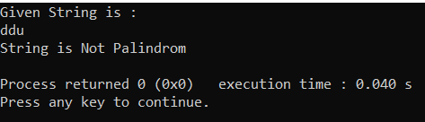

1. Write a program to implement Doubly Linked List.

#include<stdio.h>

#include<stdlib.h>

struct node{

int data;

struct node *prev;

struct node *next;

}*head=NULL;

void insert(int data)

{

struct node *newnode,*temp;

newnode=(struct node*)malloc(sizeof(struct node));

newnode->data=data;

newnode->next=NULL;

newnode->prev=NULL;

if(head == NULL)

{

head=newnode;

newnode->next=NULL;

newnode->prev=head;

}

else

{

temp=head;

while(temp->next != NULL)

{

temp=temp->next;

}

temp->next=newnode;

newnode->next=NULL;

newnode->prev=temp;

}

}

void Delete()

{

struct node *temp;

if(head == NULL)

{

printf("LINK LIST EMPTY\n");

}

else

{

temp=head;

while(temp->next->next != NULL)

{

temp=temp->next;

}

temp->next=NULL;

}

}

void write_into_file()

{

FILE *out_file;

out_file = fopen("Link_list.txt","w");

if(out_file == NULL)

{

printf("error\n");

}

struct node *temp;

temp=head;

while(temp != NULL)

{

fprintf(out_file,"%d\n",temp->data);

temp=temp->next;

}

fclose(out_file);

}

void read_from_file()

{

FILE *in_file;

int n;

in_file = fopen("Link_list.txt","r");

if(in_file == NULL)

{

printf("error\n");

}

while(fscanf(in_file,"%d",&n) != EOF)

{

insert(n);

}

fclose(in_file);

}

void Display()

{

struct node *temp;

temp=head;

while(temp != NULL)

{

printf("[ %d ] -> ",temp->data);

temp=temp->next;

}

}

void main()

{

read_from_file();

int ch,data,ser;

printf("DOUBLY LINK LIST\n");

printf("1.INSERT\n");

printf("2.DELETE\n");

printf("3.DISPLAY\n");

printf("4.EXIT\n");

do{

printf("\nEnter Your choice : ");

scanf("%d",&ch);

switch(ch)

{

case 1:

{

printf("Enter Data : ");

scanf("%d",&data);

insert(data);

write_into_file();

break;

}

case 2:

{

Delete();

write_into_file();

break;

}

case 3:

printf("\n\t");

Display();

break;

case 4:

return;

default:

printf("\tEnter Proper Choice : \n");

}

}while(ch != 4);

}

